lesson plan (4th Grade Math)

Date: 1/21

Lesson Information |  |  |  |  |  | Title: | U6: 2.3 Capture Fractions
Common Core Standard: |  |  |  |  | 4.NF.2. Compare two fractions with different numerators and different denominators, e.g., by creating common denominators or numerators, or by comparing to a benchmark fraction such as 1/2. Recognize that comparisons are valid only when the two fractions refer to the same whole. Record the results of comparisons with symbols >, =, or <, and justify the conclusions, e.g., by using a visual fraction model.
Objective: | SWBAT compare fractions using a visual model.
Key math concept: |  |  |  | sometimes we can use visual models to compare fractions, but this doesn't always work!
Anticipated Confusion:
Vocabulary:
Materials: Fraction Card Poster, Student Fraction Cards, Capture Fraction directions, Equivalent Fractions poster from before, Strategies for Comparing Fractions poster
Lesson Plan |  |  | Include questions in bold, modifications in italics
Launch:  (1 minutes) |  |  | During the next few days, we will work on comparing two fractions and decide which one is a larger portion of the same sized whole. Today, you’ll learn a new game called Capture Fractions and will practice using/creating visuals to determine which fraction is bigger.
Explore:  (4 minutes) |  |  | fraction 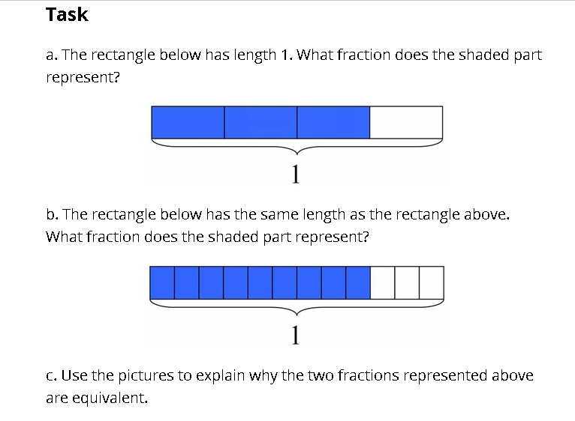  Teacher should be looking for scholars that:  - have different sized wholes, unequal parts  - used correct sized parts and wholes
Debrief:  (10 minutes) |  |  | Questions to ask:  - What are the two fractions?  - What is the relationship between the two fractions?  - How did you use the visual to compare each fraction? >  - Why are you able to use the models to compare the fractions? (Refers to the same whole)  Pull out a scholar’s explore work that had unequal parts OR used a different sized in their visual for Part B.  - Looking at the scholar’s visual, what do we notice about their representation? (If not, push to – are the parts of the visual equal? Are they referring to the same whole?  - (Teacher corrects misconception by drawing visuals with different sized wholes and same shaded parts – e.g.: 1/3 of different sized whole)  - \  Today, we’re going to be playing Capture Fractions. This game is modeled on the familiar game of War. In this version, the person with the larger fraction wins each round. Show the directions to the class on the ELMO and begin playing with co-teacher. When each person turns, their card, present it in the form of a problem like the one below so that scholars practice using the inequality signs.  Compare and $\frac{5}{6}$ using >,<, or =.  After teachers are done modeling, pose the following questions:  - How do the visuals help you compare the fractions?  - How did the teacher know that one fraction was greater than the other? (MUST REFER TO THE SAME WHOLE and there was more shaded in one fraction than the other)  Model using the visuals on the back of the cards to solve.  As students play, tell them they will be recording equivalent fractions that come up during the game on SAB pg. 33.
Apply:  (35 minutes) |  |  | Have fraction tiles at hand for this activity to supplement the fraction cards.  Students play capture fractions.  Strategic Interruption during Apply: Put up two cards that kids were able to compare without the pictures and have them quickly explain why. (take student responses) You’re not always going to have visuals in front of you to use (and even so, we know visuals are sometimes tricky because…) As we continue through this investigation, we’re going to be thinking about other strategies to use. As you continue to play, think of other ways you could determine which fraction was larger if you didn’t have a visual to look at.
Closing :  (2 minutes) |  |  | Quickly ask students what equivalent fractions they found. How do you know they are equivalent, aside from looking at the pictures?  Today, we primarily used visuals to compare fractions.  What other strategies might you use to compare fractions? (Start a poster titled “Strategies for Comparing Fractions”)  Were there any challenging fractions to compare? How did you and your partner decide which fraction was greater?  Over the next few days, we’ll think about other mathematical ways to compare fractions.
Assessment:  (3 minutes): |  |  | Checklisting of Capture Fractions playing.
Homework: |  |  | SAB 34-35

